Umm Al Qura University

College of Engineering and Computers in Al-Qunfudhah

Department of Computer Science

" Software documentation and technical writing "

PROGRAM NAME: **IHERB**

PREPARED BY:

|  |  |
| --- | --- |
| Name | ID student |
| Aryam yassin alajlani | 444010283 |
| Remas mohammed alsefri | 444006726 |

Dr. Mouna Alofi

**1.What Is iHerb?**

iHerb is an online store that focuses on selling health and wellness products, like vitamins, supplements, and organic foods. It's designed to make shopping for these items easy and accessible for everyone.

**2.The main 3 tasks that the software can do**

* 1. **Browse and Search:** Find products quickly using the search feature.
  2. **Manage Orders:** Keep track of your orders easily.
  3. **Shipping & Delivery:** Get your products delivered right to your door.

**3.How iHerb Helps**

iHerb makes it easy to find products that aren't available in your local stores, offers affordable prices, and guarantees high-quality, original items from trusted brands.

**4.What iHerb Can Do for You**

iHerb takes care of your health needs by offering a wide range of vitamins and supplements. It makes shopping super convenient since you can do it from home, saving time and effort. Plus, it helps you make smart choices with helpful information and reviews.

**5.Functional Requirements**

iHerb lets you easily search for products with keywords, create and manage your account (including viewing your order history), and modify items in your shopping cart before checkout. It also supports secure payments with various options and helps you track your orders, providing easy returns if needed.

**6.Non-Functional Requirements**

The system makes sure the website loads instantly, keeps your data safe with encryption and secure logins using your password and email or phone number, and offers a super easy, user-friendly interface that anyone can navigate.

**7.What Our Users Said**

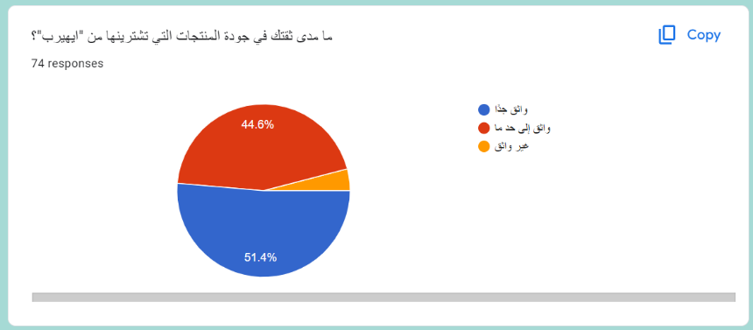 We asked more than 70 people about their experience with iHerb, and here’s what we found out:

Most users trust iHerb’s products.

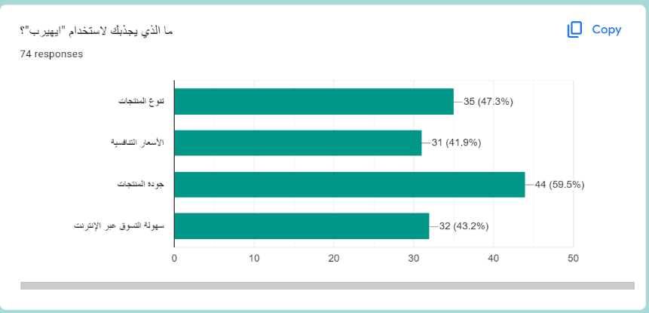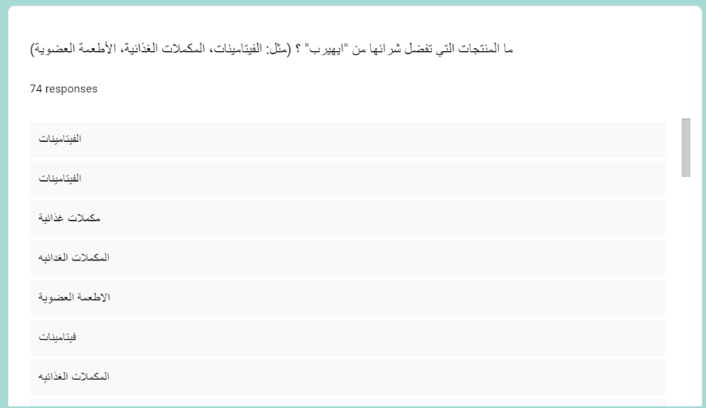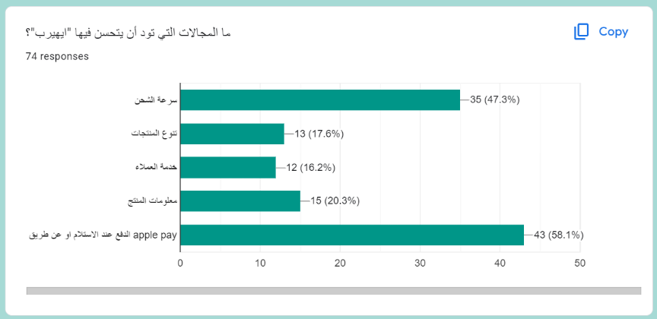

Figure 7.1

Figure 7.1

Figure 7.1

Figure 7.2

*(These results are from Saudi users.)*

Vitamins and supplements are the most popular items, but fewer people buy cosmetics. We suggest partnering with more makeup brands to improve this section.

Only 41% were drawn in by the prices, so we think offering more discounts would help.

More Payment Methods: 58% want more options for payments.

Faster Delivery: 47% wish for quicker delivery times.

**8.iHerb vs. Vitscoast**

We compared iHerb with Vitscoast, another health and wellness online retailer. Here’s what we found:

|  |  |  |
| --- | --- | --- |
|  | iHerb | Vitscoast |
| Product Browsing and Search | It has great search and filtering tools that help you quickly find the exact products and brands you want. | It has a friendly interface for easy browsing, though it could use more filtering options. |
| Order Management | It provides easy-to-use order tracking and management tools to make your shopping experience even better. | It offers simple order management, but it could benefit from more advanced tracking and management options. |
| Shipping and Delivery Management | It usually offers fast shipping and multiple delivery options, making it a reliable choice for getting your orders on time. | Shipping times might be a bit slower during peak seasons, and there are fewer shipping options available. |

**8.1. Summary:** While Vitscoast offers a simple shopping experience at lower prices, iHerb stands out with its wide product variety, efficient order management, and faster shipping. It’s perfect for anyone looking for a smooth and reliable online shopping experience.

**9.The structure of Iherb**

The system structure of Iherb can be broken into several layers:

9.1. User Interface (UI): This is the visual component that customers interact with on the iHerb website and mobile app. It includes features such as product listings, search functions, and account management, designed for ease of use.

9.2. Application Layer: This layer handling order processing, customer accounts, and inventory management. It ensures seamless transactions and efficient operations.

9.3. Database Layer: This layer stores critical information, including user profiles, product details, and order histories. It allows for quick data retrieval and updates as needed.

9.4. API Layer: This component connects iHerb with external services, such as payment processors and shipping providers. It ensures secure transactions and timely order fulfillment.

9.5. Security Layer: This layer implements measures to protect user data. It includes authentication and encryption protocols to safeguard personal and payment information.

This structure supports a secure, efficient, and user-friendly shopping experience.

Figure 9.1

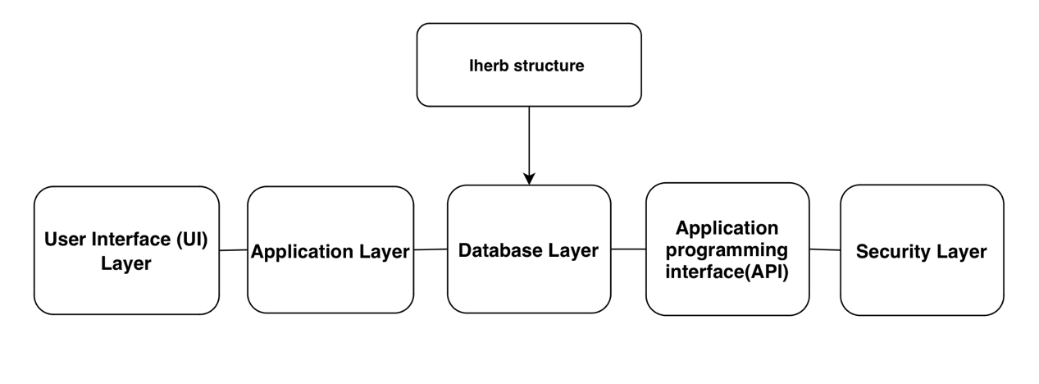

**10.Data model**

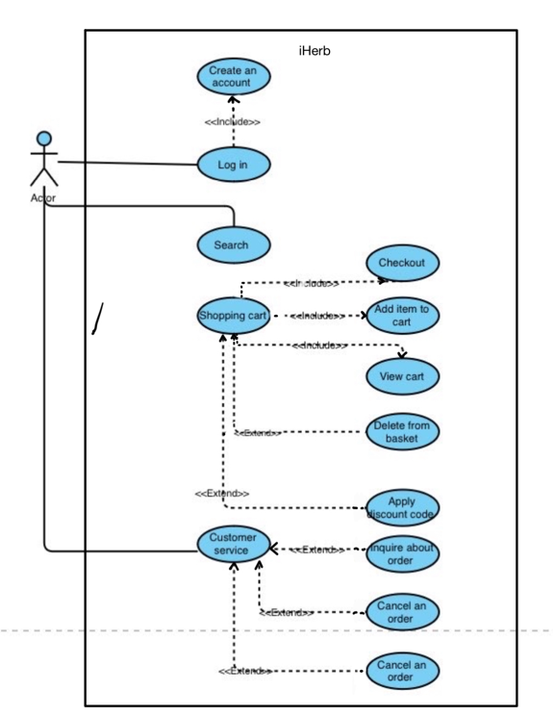Use case shows us how the user (actor) interacts with the system as it shown in figure 10.1.

Figure 10.1



10.1. Create an account: The user can create a new account, and this action includes the Log in process.

10.2. Log in: The user can log into the system.

10.3. Search: The user can search for items on the platform.

10.4. Shopping cart: The user can interact with the shopping cart, and it includes the following actions:

* + 1. Add item to cart: The user can add items to the shopping cart.
    2. View cart: The user can view items already added to the cart.
    3. Delete from basket: The user can remove items from the cart.
    4. Checkout: The user can proceed to the checkout process.
    5. apply a discount code: the user has the option to apply a discount code.

10.5. Customer service: it’s used to assist users in various aspects of

their shopping experience.

* + 1. inquire about an order: the user can seek information regarding their existing order.
    2. cancel an order: the user is allowed to cancel their order under certain conditions.

**11.Appendix**

We used the Microsoft-style guide.

The GitHub link: <https://github.com/Aryamandremas/Iherp-documentation->